Curriculum Assessment
Kellogg Community College
ADN Program

Anita L. Riddle, BSN, RN
Ferris State University

Curriculum Assessment of Kellogg Community College ADN Program
The Associate Degree Nurse (ADN) has always been a valued member of the health care team. As staff nurses, the ADN is trained, and licensed to perform the same technical skills as the BSN. The focus of the ADN program is task oriented, fulfilling technical training requirements, such as administering medication, starting IV’s, etc. The strong technical training allows the ADN to take a portion of the workload off the BSN, allowing them to function in a leadership role. Many patients do not know or care if the registered nurse providing their health care is an ADN or BSN educated professional. The patient’s primary concern is the quality of care they are receiving, and the competency of the nurse providing it.
It is important to pursue a BSN, however; the ADN as an entry level into practice needs to remain an option at this time in the profession of nursing. “The associate degree is listed as the most significant source of postsecondary education to supply the need for the projected growth in the nursing profession” (Starr, 2010, p. 130). This supports the ADN as a much needed commodity in the nursing workforce. “It is time to consider, in the context of health care reform, not only the shortage in the number of nurses, but also the shortage of nurses educated to perform in the complex health care system of the future” (Ellenbecker, 2010, p. 115).
The KCC nursing program is respected by the community and area health care organizations. It has made many transitions over the past decade. As a KCC graduate, and current student mentor, I have personally witnessed some of the changes this program has undergone. With the uncertain implementation of the Affordable Care Act, all nursing curriculums will undergo assessments and implement changes. The purpose of this paper is to analyze the Kellogg Community College associate degree nursing program and curriculum, identify curriculum strengths and weaknesses, and make recommendations using Keating’s (2011) curriculum assessment process.
Curriculum Identification
KCC is located in Battle Creek, Michigan. It currently serves approximately 14, 500 students annually. The student population is primarily generated from Barry, Branch and Calhoun counties.
Community College was founded in 1956 by the Battle Creek Board of Education which operated it until 1970 when voters created an area-wide college district. The College, operating on sites in Battle Creek, Albion (Eastern Academic Center), Coldwater (Grahl Center), Hastings (Fehsenfeld Center), and Fort Custer Industrial Park (Regional Manufacturing Technology Center), offers nearly 100 pre-professional college/university transfer curricula; approximately 40 occupational associate degree programs in health, business, secretarial, technical and public science fields; and over 30 certificate programs aimed toward job preparation; and related training for apprenticeships. (Kellogg Community College, 2013, “About KCC”, para 1)
KCC offers both a full-time and a part-time Ladder Curriculum Option. By attending on
a full time basis, the nursing student can graduate in four semesters with an Associate in Applied Science, and be eligible for the RN-NCLEX. When choosing the part-time option the student will need to set aside seven semesters for completion. KCC also offers an advanced placement option for those students who are Licensed Practical Nurses, requiring only three semesters. Each option requires specific pre-requisites (16 credits) prior to entering.
External Frame Factors
Although there are many steps in a curriculum needs assessment or the redesigning of an academic nursing curriculum, the examination of the external framework is an essential step. This process provides a means to identify the dynamics of the environment surrounding the academic institution or healthcare organization. Keating (2011), has identified nine frame factors to be considered during the assessment
- community demographics;
- demographics of enrolling students;
- academic settings;
- political climate;
- health care system and population needs;
- need for a nursing program or re-design;
- nursing profession;
- regulations and accreditation; and
- financial support (Keating, 2011, pp. 117-119).
Community
The physical location of the learning institution will dictate the academic and financial success of a nursing program. Just as in business, there must be a need, easy safe access, the financial support of area businesses and organizations, and a high rate of employment in the area the skill or trade was acquired to be successful. Other considerations such as housing, shopping and recreation need to be assessed.
KCC is located in an urban area, just blocks north of downtown Battle Creek. With nine public school systems in Calhoun County alone, there are ample students to apply. There are many health care organizations, providers, and academic opportunities within Battle Creek and the near-by city of Kalamazoo for employment after degree completions. KCC forms unique joint admission agreements with four year institutions such as Western Michigan University and Miller College (KCC, 2013, “Fast Facts,” para. 11).
Student Demographics
The demographics of the students and potential students play an important role in the success of the curriculum. Characteristics of the students such as gender, age, socioeconomic status, desire of full-time or part-time programs, will set the stage in determining the direction a curriculum takes. The times the courses are offered, day, afternoon, or night may dictate the number of students attending them. “Another consideration related to demographics is the existence of potential faculty and identification of people who have the credentials to teach” (Keating, 2011, p. 94). Currently, all full time KCC nursing faculty are Master’s prepared, with the adjunct clinical instructors holding Bachelor degrees.
KCC’s nursing program has expanded admissions greatly over the years with approximately 150 nursing students admitted each fall. The student population is not diverse in nature. In 2011, there were 129 nursing graduates, with 116 females and 13 males (Match College, 2013, “Students Enrolled,” para. 3). The nursing student population is primarily white non-Hispanic. The students who are currently job shadowing me are in their late twenties, thirties and forties. Several travel two or more hours to attend due to the wait time at their near-by learning institutions.
Academic Setting
KCC shares a campus with Miller College which offers a RN-BSN nursing program. “Miller College has articulation agreements with most of the community colleges surrounding Battle Creek that offer RN programs – Kellogg Community College, Kalamazoo Valley Community College, Jackson Community College and Glen Oaks Community College in Centreville” (Miller College, 2013, “Programs,” para. 7). Miller College also allows students waiting to be admitted to a community college nursing program to start BSN core classes and then return after completion of their associate degree. With a shorter wait time for entry into the nursing program, KCC is currently attracting nursing candidates at a rapid pace.
Political Climate
KCC is well established in the Battle Creek community. As one might presume, anything with the Kellogg name will remain strong for years to come. The KCC nursing program is well respected. The core components of the mission statement reflect the institution’s commitment to the Battle Creek community and the surrounding area. “We partner with the communities we serve to support economic vitality and stability through the development of a skilled local workforce” (KCC, 2013, “Mission Statement,” para. 2). The nursing program’s mission statement also shares this core value.
Health Care System
Bronson Battle Creek Hospital is located next to the KCC campus. There are also several extended care facilities, physician’s offices, outpatient surgical centers, home health, a public health department, hospice services and an urgent care. Borgess Hospital is opening a satellite location for outpatient services in 2014. Kalamazoo is approximately thirty minutes to the west and supports two major hospitals. Oaklawn Hospital is twenty minutes to the east. This gives KCC students four acute care clinical sites within easy driving distance. Health care provisions in the area are adequate at present for those who are insured. There is not a wait time for physician appointments and/or hospital admissions. On the other hand, there is a need for more health care and nursing services to be available for those covered by Medicaid and Medicare.
Need for Program
Even with the current recommendations for entry level into practice, the ADN still has a strong following. This view stems from the fact the ADN represents the majority of the current registered nurse workforce. “Associate degree nursing is in a unique position to address two challenges currently facing the nursing profession - the shortage of registered nurses and the lack of adequate numbers of baccalaureate degree prepared nurses” (Starr, 2010, p. 129). Completion of the ADN program can be attained in three years, cutting cost, and placing the registered nurse into the workforce sooner. The ADN option offers many candidates a career opportunity they may not otherwise have. These programs are offered at community colleges, and many classes are scheduled at night allowing the candidates to work while attending.
With approximately 10,000 baby boomers turning 65 daily, the demand for registered nurses will continue to grow. Located in Calhoun County, ranking 78th in poor health outcomes, the continued need for registered nurses is evident (Robert Wood Johnson Foundation, 2013). Calhoun County still has a high tobacco use and obesity rate. There is an unrelenting need for nursing professionals to provide care, research and education to the public. In order to produce the number of nursing professionals at the rate needed, the ADN program will remain a successful and viable option.
Nursing Profession
There are professional nursing organizations available to support the nursing profession. On the national level the American Nurses Association is one option. Many nurses both ADN and BSN are members of the Michigan Nurses Association either by choice, or as a condition of their employment related to union membership. Many of my peers are also members of nursing organizations specific to their area of practice.
For many years, the majority of nurses in this area have been ADN prepared. I believe this is partially related to the convenience of the KCC nursing program. Secondly, as mentioned above, the ADN programs is less expensive and requires less time. Bronson Battle Creek Hospital will currently hire ADN prepared nurses with the commitment to obtain a BSN within five years of hire.
Regulation and Accreditation Requirements
KCC is accredited through the Higher Learning Commission of the North Central Association of Colleges and Schools, Council on Accreditation of Allied Health Programs, Council on Accreditation of Allied Health Programs, and the State of Michigan Board of Nursing (State University, 2013, “Accreditation,” para. 5). The current curriculum appears to be in compliance with these accreditation agencies. Any changes in the current ADN curriculum would require a review to assure they continue to meet or exceed the requirements for local and national standards.
Financial Support
A complete analysis of the financial stability of the ADN program would be an essential part of a curriculum re-design. A new budget may need to be developed and possibly new partnerships developed. “Other items of study include how the program is financed and the major sources of revenues such as fees, tuition, state support, private contributions, grants, scholarships or endowments” (Keating, 2011, p. 100). The financial stability and job market of the area may also impact the success of the nursing program.
Internal Frame Factors
Once the external frame factors have been identified, the curriculum design team can move on to the assessment of the internal frame factors. “Internal frame factors are those factors that influence curriculum development and are within the parent institution and the program itself” (Keating, 2011, p. 92). Internal frame factors to consider are
- description and organizational structure of the institution;
- mission, purpose, philosophy, and goals;
- internal economic status;
- resources within the institution and nursing program; and
- faculty and student characteristics (Keating, 2011, p. 123).
Description and Organizational Structure
KCC is well known for its allied health programs. The ADN nursing program is respected in the community and surrounding areas. The campus is small and easily navigated. Located next to the hospital, the campus provides easy access to academic courses, simulations and clinicals. The campus has grown since it originated, and with addition of Miller College, KCC will continue to attract nursing students.
The curriculum re-design will need to follow the hierarchy of the college for approval and implementation (Keating, 2011). KCC has a well-developed organizational chart to guide the direction of this process. Communication is key to assure success.
Mission, Philosophy, and Goals
Evaluation of the institution’s mission, philosophy and goals must be clear. The nursing program must reflect these goals and values through their mission statement and philosophy. KCC has an existing mission and vision statement with identified core components. It reflects the three areas needed in higher learning institutions, “education, service, and scholarship/research” (Keating, 2011, p. 125).
The KCC nursing mission and philosophy attempts to support the institution’s mission and vision statement through its first sentence “the nursing educational community shares in the mission of Kellogg Community College” (KCC, 2013, “Mission,” para. 1). The remainder of the mission statement is lengthy and could benefit from revision.
Internal Economic Status
A budget analysis of the current nursing curriculum is necessary. It is essential to determine the financial future of the existing program. If the nursing program is not self-sustained financially it may be necessary to seek other funding options prior to the expansion or re-design of the curriculum. A thorough evaluation of existing resources would be helpful prior to performing this step.
Internal Resources Available
An inventory of the nursing program’s existing resources will determine the availability and possible needs of a curriculum re-design. This may include books, classrooms, supplies, computers, technology support, medical equipment, and any other resources currently available (Keating, 2011). During this process of curriculum re-design new existing resources may be discovered.
Faculty and Student Characteristics
It is also important to consider the readiness of faculty and adjunct staff to support curriculum assessment and possible re-design. Do they have the right credentials to be educators under a new or re-designed nursing curriculum? Are the current faculty to student ratios sufficient? The student population is also important to evaluate. The race, gender and cultural diversities impact the direction a curriculum assumes. These findings may impact the method of curriculum delivery.
Key Curriculum Components
Once the institution’s external and internal framework factors are identified and evaluated, the key curriculum components need to undergo assessment. “Curriculum development and revision processes must be based on information from evaluation activities; latest changes in the profession, health care, and society; and forecasts for the future” (Keating, 2011, p. 174). Key curriculum components include
- mission or vision statement;
- philosophy;
- organizing framework;
- overall purpose and goals; and
- implementation plan (Keating, 2011).
Mission Statement
An institution’s mission statement serves as the foundation on which an academic program supports and builds its own unique vision. “Both the missions of the parent institution and its academic subdivision should be congruent with each other and provide guidelines for the mission statement of the nursing program” (Keating, 2011, p. 156). The statement needs to be concise and project clarity. There may also be a vision statement which reflects the institution’s visualization for their future.
Kellogg Community College has both a mission and vision statement (see Appendix A). Their mission statement contains five lengthy core components. The KCC vision statement has a powerful opening sentence. It then continues values they support. Although the values are honorable, I did not get a clear vision of their future direction.
The nursing program has a mission statement for their academic department (see Appendix B). They open the mission statement by stating they share the mission of Kellogg Community College. Although it supports the KCC mission statement, the remaining portion of the mission statement gives the impression of demands set for the students and faculty. There is no vision statement.
Philosophy
A philosophy statement portrays the beliefs and values of the institution and/or academic program it represents. It includes expectations and goals of both the students and faculty. Through research, I have ascertained that many institutions along with their academic programs, may not have a mission, vision and a philosophy statement. However, most have two of the three, or have a combined mission and vision statement.
KCC has a separate mission and vision statement, but no philosophy statement. Their nursing program has a mission and a philosophy statement and no vision statement (see Appendix B). The philosophy articulates clear values and beliefs, and includes input from students, educators and the nursing profession. Suggested components of an effective philosophy address
- critical thinking;
- diversity and cultural competency;
- genetics;
- social justice;
- research and evidence-based practice;
- informatics and technology;
- quality health care and patient safety; and
- nursing paradigm (Keating, 2011, p. 149).
The KCC nursing program does a good job of tackling most of the components. After carefully appraising the philosophy statement, I could not clearly identify the components of genetics, informatics, and patient safety.
Organizational Framework
From the foundation of the mission, vision, and philosophy statements, the curriculum framework is built. “Curriculum frameworks provide faculty with a way of conceptualizing and organizing the knowledge, skills, values and beliefs critical to the design of a coherent curriculum plan that facilitates student learning and their achievement of the desired educational outcomes” (Boland, 2012, p. 139). Organizational frameworks can be theory based or constructed from accreditation standards.
The nursing program at Kellogg Community College has identified five core competencies to form their organizing framework (see Appendix C). The core competencies include caring, communication, critical thinking, evidence based practice, and professionalism. The educators who developed the organizing framework appear to have taken a non-traditional approach, using accreditation standards as a guiding force. With each core competency a definition is incorporated.
Overall Program Goal and Purpose
Any academic program necessitates the clarity of the program’s purpose and desired outcomes. “Nursing faculty need to have the input of the practice sector when putting outcomes and competencies into words to ensure that what is being expressed relates to today’s and tomorrow’s reality as viewed by the practice experts” (Boland, 2012, p. 154). The program’s purpose and goals should also be reflective of the mission, vision, and philosophy statements.
After navigating the KCC website, I found it difficult to identify the overall program goal and purpose. I believe they are threaded throughout the core competencies. However, each core competency appears to present a definition and not a clear program outcome. The reader can read between the lines, and assume they are looking for a nurse who is caring, able to communicate clearly, demonstrate critical thinking skills through evidence-based nursing practice, and maintain professionalism.
Implementation
The student learning objectives (SLOs) must also support the mission, vision, and philosophy statements, as well as meet the overall program goal and purpose. It is important each student is aware of the expected outcomes of each classroom or clinical experience. “Student learning outcomes deal with attributes of the learner that demonstrate achievement of the program goals” (Sauter, Gillespie, & Knepp, 2012, p. 539). Some academic settings use end of year outcomes to designate the SLO’s achievements according to the student’s current place within the nursing program, leading to the program’s overall objectives.
KCC offers ladder curriculum options. For each option there is a calendar year goal. Looking at the full time option Level I- Calendar year one, it offers the SLO of the eligibility for the PN-NCLEX. Level II-Calendar Year 2 delineates the SLO as the eligibility to take the RN-NCLEX. Each nursing course description indirectly frameworks the SLO desired. Located in the nursing student handbook a clinical concept clearly listed the desired clinical SLO’s. The course descriptions, perquisites, schedule, credit value and grading scale are also outlined in the nursing student handbook.
Prior to implementing a new or re-designed curriculum, a final assessment should be made to assure the mission, vision, and philosophy statements, organizing framework, SLOs, and the overall program goal and purpose support each other. Once the curriculum is finalized, it will need the approval of faculty and academic organization. Even after the curriculum is rolled out, it is important to remember curriculum assessment is ongoing, and there still may be changes identified.
Analysis of Curriculum Issues
After assessing the ADN nursing program and curriculum offered by KCC, I believe the overall program is strong and will continue to be viable. Subsequently being in the nursing profession for over twenty five years, looking at an ADN curriculum makes me wonder how I functioned as a new graduate nurse with what seems to be so little training and information. However, I support the role of the ADN and recognize the vital role they have played in helping to meet the supply and demand of the nursing profession.
As indicated earlier KCC offers three curriculum options (see Appendices D, E, and F) for students seeking to enter the nursing profession, full-time, part-time, and advanced placement. All curriculum options were created using a ladder curriculum. For many students this may be viewed as a strength of the program, allowing them to become licensed as a nursing assistant, practical nurse and finally their goal of registered nurse. This curriculum option allows students seeking employment to become employed in the area of healthcare during their educational journey, while giving them an income. “Because of the shorter educational preparation of LPNs, often 12 to 18 months, compared to 2 to 4 years for RN education, LPNs are provided earlier entry into health care settings” (Cook, Dover, Dickerson, & Engh, 2010, p. 125). Working as a LPN will also reinforce the technical skills and knowledge being obtained during their ADN education.
Although the mission statement shares its institution’s mission statement, it is lengthy, and represents a set of demands rather than a set of beliefs related to the program’s teaching, service, and scholarship delivery practices (Keating, 2011, p. 154). “The identification of gaps between the two mission statements provides information about where area of attention is needed” (Sauter, Gillespie, & Knepp, 2012, p. 508). Therefore I feel the program’s mission statement is a weak link in the foundation of the curriculum.
The nursing’s program philosophy supports a learner centered approach with a dedication to life-long learning. This represents a strength of the program. It clearly gives the student the confidence their individual learning needs will be met. Their philosophy identifies the nurse educator as a mentor. The role of the instructor is that of a facilitator, guiding students to seek new information, and allowing the students to take active roles in their learning experience (All & Brandon, 2010).
After review of the descriptions and progression of courses, I discovered there was not mention of patient safety. It may be contained within the delivery of the courses, however it is not in any of the course descriptions or the program’s philosophy statement. It is however mentioned under the core competency of professionalism. Without access to the program’s syllabuses it is difficult to determine if it has actually been integrated. “The focus on patient quality, safe patient care affects all health care disciplines because each discipline has a duty to respond to the identified national patient safety concerns” (Jones, 2013, p. 140).
Technology advances are one of the most frequent changes being seen in curriculum redesign. KCC has made these changes and has access to a simulation lab on campus. It has also provided a complete orientation video on its website to give potential students insight on simulation experiences. They have also developed a very detailed student clinical handbook and have very clearly stated their expected student clinical SLOs.
The curriculum is geared toward becoming a registered nurse in an acute care setting. Although many graduates will gravitate to acute care, the Affordable Care Act is anticipated to change many health care services. “An adequate supply of nurses will be necessary for reform that emphasizes the expansion of health insurance coverage while improving the quality, safety, and efficiency of care” (Buerhaus, Auerbach, & Staiger, p. 667). The National Healthcare Plan is attempting to shift healthcare from the acute care setting to a community setting. With this in mind, KCC offers very limited access to clinical experiences to health care in a community setting.
Associate degree programs may be the most at risk for content saturation in curriculum, related to the length of the program, and the reality an ADN and BSN sit for the same state boards. “Content saturation and overly crowed curricula are a primary challenge to reform the current nursing curriculum and movement towards an evidence basis for nursing accreditation” (Keating, 2011, p. 198). This may be one reason KCC has chosen the course content and sequence of progression of their program.
A final weakness noted in the curriculum is the placement of their communication course. Communication is important enough to be a core competency and a building block of the nursing program’s organizational framework. It is also included in the nursing philosophy statement. However, they do not require the student to become formally educated in the skill until the final semesters of the program. As supported by the American Nurses Association, standard 11, communication, “the registered nurse communicates effectively in a variety of formats in all areas of practice” (American Nurses Association, 2010, p. 54). This is a skill that is required early in order to practice and refine it.
Recommendations
After assessment of the KCC nursing curriculum. I have identified the following areas suitable for curriculum redesign consideration
- revision of the nursing program mission statement;
- development of a nursing program vision statement;
- more clearly present the overall program goal and purpose;
- assess the placement of the communication requirement in the sequence of courses; and
- patient safety education.
Without access to the inside information, these deductions were made from my past experiences as a KCC student, experienced nurse, and limited experience as a nurse educator.
Mission Statement
The mission statement of a nursing program not only serves as the foundation for the curriculum and program, it may be a perspective student’s first impression. The mission statement needs to quickly summarize the purpose of the nursing program, while continuing to support KCC’s mission as a whole. They attempt to convey the support of the organization’s overall mission in their opening sentence by stating they share the mission of KCC. As they continue their mission statement, I felt the information was demanding and may better serve as SLO’s.
Although the mission statement contains many key buzz words such as critical thinking and lifelong learners, this mission statement does not reflect a clear purpose. As a reader, I do not want to read between the lines to acquire an understanding. Maybe they are trying to test critical thinking skills by making the reader use their metacognition. A clear, concise mission statement, one a student can easily repeat and recall is needed.
Vision Statement
KCC as an academic institution has a statement of vision. A nursing program is not required to have a formal vision statement. However, as a potential student, it would pull me towards this program if I felt it was progressive, and able to share their vision of the nursing program’s role in the future health care. Even as a past and current student, I have had a vision of where I was headed in my profession, and it would be helpful to know if the learning institution shared it.
Overall Goal and Purpose
After researching the KCC website, I was unable to identify the desired overall program goal and purpose. I searched through the Nursing department’s web pages, nursing program and clinical student handbooks. This is a strong and respected program, so I suspect they are documented somewhere other than their website. Since neither were attainable by this route, it may behoove them to add them to their website. Society is connected by the internet, the more KCC shares with their perspective students the stronger the nursing program will become. Students want to be prepared and need to know what they are accountable for.
Communication
As identified earlier, KCC has selected communication as a core competency and building block of their organizing framework. So why is Communication 101 or 111 not offered earlier in the sequence of the curriculum? It is not required at all for the advanced placement option. I believe this course should be moved to the first semester or even become a prerequisite if it is important enough to be a core competency. As nurses, we all know the importance of clear concise communication. “Good communication is essential in establishing trust between nurses, patients, as well as their family members which forms the foundation of good health care” (Xie, Ding, Wang, & Liu, 2012, p. 823). These skills are not optional, they are required. By incorporating this course earlier in the program, the student’s overall educational experience may be improved.
Patient Safety Education
Patient safety is another hot topic in nursing. “Because nurses comprise a tremendous sector of the health care delivery system, it is imperative that the nursing profession address the national concerns regarding quality and safety in patient care” (Jones, 2013, p. 140). KCC has incorporated safety under the professional core competency. After reading the course descriptions I was unable to clearly determine the extent patient safety was incorporated or what standards they used. “The concept of safety needs to be incorporated throughout the entire nursing curriculum, beginning with the students’ first nursing course and threading throughout the nursing curriculum” (Jones, 2013, p. 141). I know the nurse educators and clinical instructors use safety standards, however are they QSEN, where are they made visible to the student? Certainly an assessment at the minimum would be in order.
Conclusion
The process of curriculum assessment is crucial in order to maintain the most current evidence-based nursing program available. The KCC associate degree nursing program is well established and has undergone many transitions over the past five decades. Their ongoing dedication to the community has been evident through their growth to include Miller College on their campus.
The curriculum assessment revealed many strengths exhibited within the KCC nursing program. The strategic campus location, support of the community, full time Master’s prepared faculty and past history of curriculum re-design all contribute to its long standing success. The full-time, part-time, and advanced placement program options add flexibility which adds to its future success.
Any nursing program when put under a microscope will discover weaknesses and areas for growth. Even with the components identified in this paper, revision of the mission statement, development of a written vision statement, clear identification of overall program purpose and goals, consideration related to moving the communication course earlier in the program, and evaluation of patient safety education, the KCC nursing program is creditable and well organized. The fast pace health care system ensures the KCC nursing faculty will continue its endeavor to maintain a quality evidence-based associate degree nursing program curriculum.

References
All, A., & Brandon, A. (2010). Constructivism theory analysis and application to curricula.
Nursing Education Perspectives, 31(2), 89-91.
American Nurses Association. (2010). Scope and standards of practice (2nd ed.). Silver Spring,
MD: Nursesbooks.org
Buerhaus, P., Auerbach, D., & Staiger, D. (2009). The recent surge in nurse employment: Causes
and implications. Nurse Employment, 28(4), 657-668).
Boland, D. (2012). Developing curriculum frameworks, outcomes, and competencies. In D.
Billings, & J. Halstead, (Eds.), Teaching in nursing: A guide for faculty. (pp.138-159). St.
Louis, MO: Elsevier.
Cook, L., Dover, C., Dickerson, M., & Engh, B. (2010). Returning to school: The challenges of
the licensed practical nurse to registered nurse transition student. Teaching and Learning in
Nursing, 5(3), 125-128.
Retrieved from http://www.sciencedirect.com/science/article/pii/S1557308710000284
Ellenbecker, C. (2010, August). Preparing the nursing workforce of the future. Policy, Politics,
& Nursing Practice, 11(2), 115-125. doi:10.177/1527154410380142
Jones, A. (2013). The impact of integrating quality and safety education for nurse’s safety
competency in first-year associate degree nursing students. Teaching and Learning in Nursing
8, 140-146. Retrieved from http://dx.doi.org/10.1016/j.teln.2013.06.001
Keating, S. (2011). Curriculum development and evaluation in nursing, (2nd ed.). New York,
NY: Springer Publishing Company.
Kellogg Community College. (2013). About KCC. Retrieved from
http://www.kellogg.edu/about/index.html
Kellogg Community College. (2013). Fast facts. Retrieved from
http://www.kellogg.edu/about/fastfacts.html
Kellogg Community College. (2013). Mission statement. Retrieved from
http://www.kellogg.edu/about/mission.html
Kellogg Community College. (2013). Sequence. Retrieved from
http://www.kellogg.edu/alliedhealth/nursing/pdf/sequence.pdf
Match College. (2013). Students enrolled. Retrieved from
http://www.matchcollege.com/community-colleges/kellogg-community-college/nursing Miller College. (2013). Programs. Retrieved from
http://www.millercollege.edu/academics/programs
Robert Wood Johnson Foundation. (2103). Canton health rankings and roadmaps. Retrieved
from http://www.countyhealthrankings.org/app/michigan/2013/calhoun/county/outcomes
Sauter, M., Gillespie, N., & Knepp, A. (2012). Educational program evaluation. In D.
Billings, & J. Halstead, (Eds.), Teaching in nursing: A guide for faculty. (pp. 503-549). St.
Louis, MO: Elsevier.
Starr, S. (2010). Associate degree nursing: Entry into practice-link to the future. Teaching and
Learning in Nursing, 5, 129-134. doi:10.1016/j.teln.2009.03.002
State University. (2013). Accreditation. Retrieved from
http://www.stateuniversity.com/universities/MI/Kellogg_Community_College.html
Xie, J., Ding, S., Wang, C., & Liu, A. (2102). An evaluation of nursing students’ communication
ability during practical clinical training. Nurse Education Today, 33, 823-827.

Appendix A
Mission Statement
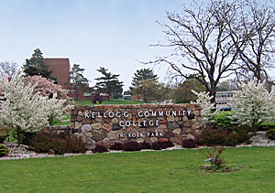
"We are dedicated to providing accessible, high-quality education to enrich our community and the lives of individual learners."
Core Components of our Mission
- We engage students in learning experiences that lead to enhanced employability and successful transfer to other educational institutions.
- We develop students who can think critically, communicate effectively, and demonstrate global awareness
- We partner with the communities we serve to support economic vitality and stability through the development of a skilled local workforce.
- We provide the educational resources and student services that promote, support, and enhance student success.
- We advocate lifelong learning for all members of the community, providing local residents with educational and cultural opportunities that result in personal growth and development.
Statement of Vision
Kellogg Community College will be recognized as a premier institution of higher education, having achieved excellence through innovation, quality instruction, a culture of continuous improvement, and learner-centered decision making.
Working together across the college, we support an environment that values:
- Student success through collaboration, cooperation, and academic rigor
- Positive relationships with students, employers, our staff, and the community
- Diversity
- Quality and continuous improvement
- Innovation, creativity, and flexibility
- Personal and professional integrity, and accountability
- Staff development

(Kellogg Community College, 2013)

Appendix B
MISSION
The nursing educational community shares in the mission of Kellogg Community College. By providing excellent educational experiences, we support scholarly endeavors for all individuals who have achieved admission to the various Nursing Programs. Our Nurse Educators serve as facilitators of the learning process, encouraging all students to achieve their potential. As members of the academic community, students are accountable partners in the learning process which incorporates evidence based practice, critical thinking, and lifelong learning. Students are prepared to practice as beginning nurse generalists to meet health care needs in a global society. We expect that every member of our academic community will adopt and enhance this mission.
PHILOSOPHY
The statement of philosophy expands on the mission of the nursing education community and further articulates beliefs that have been integrated throughout the curriculum. The philosophy of the Kellogg Community College Nursing Department evolves from beliefs regarding the student, nursing discipline, and nursing education to prepare the beginning nurse generalist to practice in a global and rapidly changing health care environment.
Each student brings diverse attitudes, knowledge, skills, life experiences, learning needs and styles that require varied approaches to the learning process.
Nursing is a dynamic discipline generated from a professional body of knowledge, skills, values, meanings and experiences. Through autonomous and collaborative decision making, the nurse applies the related core competencies of which include caring, communication, critical thinking, evidence based practice, and professionalism.
Nursing education is research based; reflective of health care trends, incorporating innovation, technology, and creative instructional methods. Nurse Educators design student-centered, individualized learning experiences for diverse student populations. The role of the Nurse Educator is one of guiding, facilitating, and mentoring the learner to promote the value of life-long-learning within the nursing profession.

(Kellogg Community College, 2013)

Appendix C
Core Competencies/Organizing Framework - Nursing
The organizing framework has emerged from the core competencies identified in the philosophy statement.
Caring
Caring is the essence of nursing. It is a moral ideal of assisting, supporting, and enabling human beings to meet anticipated health needs and to promote personal development. A nurse purposefully initiates caring behaviors to build helping relationships and create a healing environment. The caring nurse provides hope, empathy, compassion and therapeutic interventions to help patients achieve desired outcomes in a collaborative environment. The caring approach to nursing practice affirms the dignity and worth of all persons.
Communication
Communication is an exchange of information, both verbal and nonverbal, between a sender and a receiver. Therapeutic communication is the cornerstone of the nurse/client relationship; planned and directed by the nurse to achieve mutually determined client outcomes. The nurse utilizes excellent communication skills in collaborating with all members of the health care team in order to advocate for clients, as well as to realize organizational goals. The nurse identifies themes, utilizes empathic listening skills, is genuine, and remains cognizant of what is said and what is left unsaid. Effective communication is facilitated in order to provide the best possible client care.
Critical Thinking
Critical thinking is a complex process involving creative, purposeful, informed, and outcome-focused thinking to actively process and evaluate data. Nursing education incorporates cognitive, affective, and psychomotor learning experiences within the nursing process to foster this essential component of professional accountability and quality nursing care.
Evidence Based Practice
Evidence based practice is a nursing research driven approach to clinical decision making. Nursing education utilizes a scientific problem solving methodology to cultivate an environment that stimulates inquiry and presents rationale for best practice clinical standards in the delivery of adaptive quality nursing care.
Professionalism
Professionalism is a set of attributes that demonstrates a nurse’s public responsibility and commitment to providing safe, effective and high quality care. The professional nurse’s actions are unrestricted by the client’s social, economic, personal attributes and health problems.
(Kellogg Community College, 2013)

Appendix D
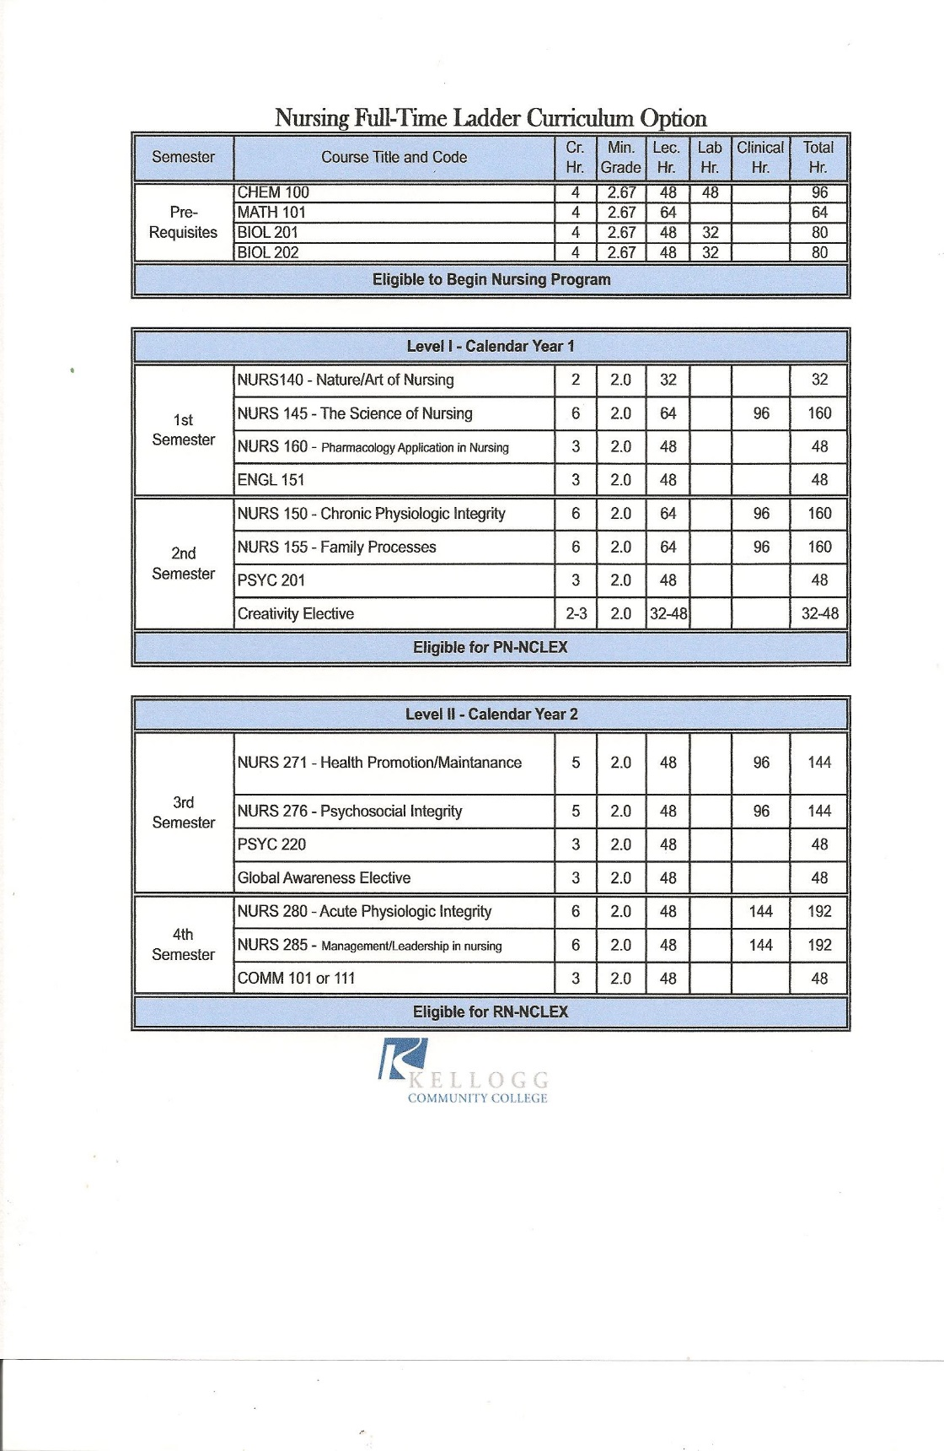
(Kellogg Community College, 2013)
Appendix E
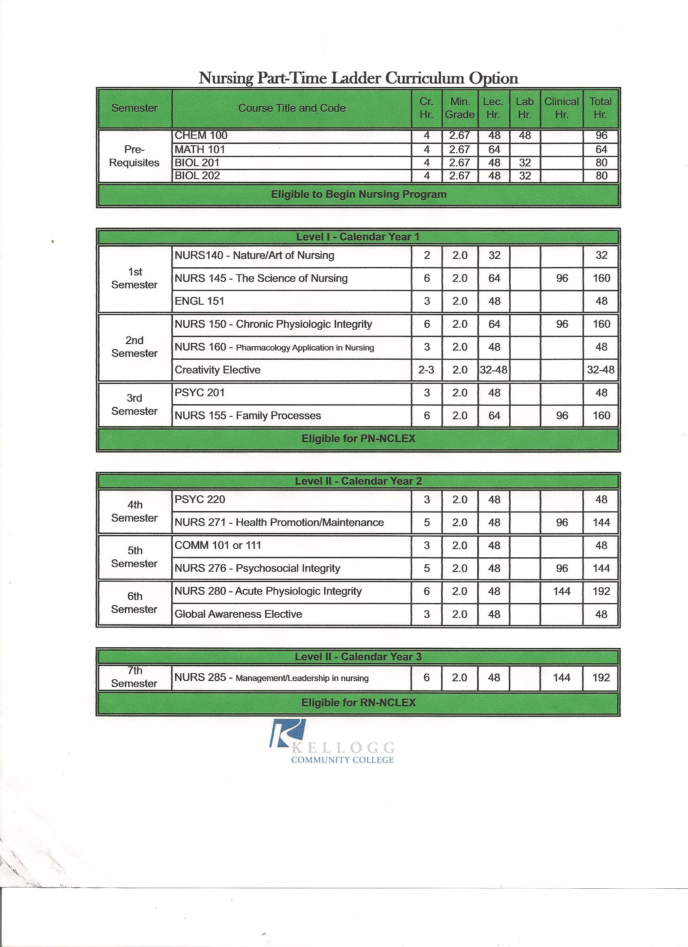

(Kellogg Community College, 2013)

Appendix F
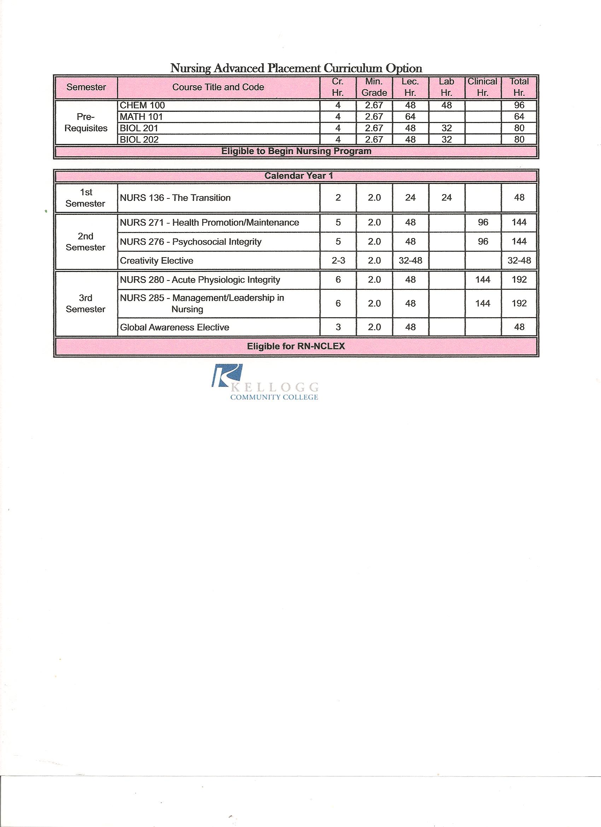

(Kellogg Community College, 2013)

