Part A: PLAN (NURS 711)
A. Quality Improvement Project.
This project will focus on improving the influenza vaccination rates of the adult African American population in Calhoun County. The current methods of flu immunization will be evaluated in the nursing clinic and community flu clinics. Included in this investigation will be the locations of 2014-15 flu clinics, education currently available to the African American community, and marketing methods utilized. Information obtained will be implemented into the 2015-16 flu campaign.
To obtain some preliminary information, and an increased understanding of Calhoun County Public Health Department’s (CCPHD) flu immunization plan, I have volunteered to assist with the scheduled community flu clinics. Participation will allow direct contact with the target population. A visual assessment of the races, ethnicities, genders, and ages attending will provide direction for further research to develop the 2015-16 immunization plan. Through a root cause analysis (RCA), this information will be dissected, and reconstructed to formulate an immunization plan in alignment with the organizational strategic plan.
The nursing clinic’s current flu immunization practices will be included in the investigation. Again, consideration will be given to the race, ethnicity, gender, and age of the clients they serve. An assessment of the clinics’ patient education practices, or lack of related specifically to the flu vaccine will be completed. Time permitting other departments may be evaluated for opportunities to educate, and refer clients to the CCHPD nursing clinic for flu immunizations.
The evidence obtained will be reviewed. A collaborative approach will be utilized to develop a comprehensive approach to increase the influenza vaccination rates in the adult African American population. The final plan will then be presented for approval by the Personal Health Officer and Health Officer of CCPHD. At this time, it is unclear if a percentage of improvement goal will be set, a client survey utilized, or the acceptance of an evidence-based influenza program implemented will serve as the appraisal tool. A desired side effect would be an increased awareness and influenza vaccination rate in all adults in Calhoun County.
Immunizations provide an added layer of protection against vaccine-preventable communicable diseases. The immunization of populations is important to all races, genders, and ages. As a public health care provider, the CCPHD offers another venue to this underserved population.
B. Evidence based support for this project.
Ranking 4th in the state of Michigan, Calhoun County has only achieved a 25.9% flu vaccination rate for all persons >6 months old (MDCH, 2014, “Influenza Vaccination”). However, at the national level Michigan ranked 42nd during the 2012-13 flu season (MDCH, 2014, “Influenza Vaccination”). These statistics represent low overall flu vaccination rates at both the state and national levels. Low flu vaccination rates contribute to increases in chronic health co-morbidities and mortality rates annually.
Currently, the CCPHD clients are equally represented with white, and African American races equally represented at 49%, with 2% falling into other (M. Thorne, personal communication, September 30, 2014). Although the white and African American populations are equal, African Americans are under vaccinated in all areas including flu. This same data holds true at the national level. In 2012, white adults >18 were vaccinated for the flu at rates 10% higher than the African American population (CDC, 2014, “Flu Vaccination Coverage”).
Calhoun County has a population of approximately 135,000, with an 11% African American population (MDCH, 2014, “Michigan Influenza”). Although I was not provided with immunization statistics at this time, an 11% African American population equates to approximately 15,000 individuals of various ages living in Calhoun County. Areas of question arising from a meeting with the CCPHD Health Officer were related to current nursing clinic flu immunization practices, community flu clinic immunization practices, locations, and marketing methods. Through a root cause analysis, possible barriers to African Americans in receiving the flu vaccine, such as: transportation, payment methods, lack of flu education, and misconceptions about receiving the flu vaccine were explored.
In 2007, a study was conducted by Chen, Fox, Cantrell, Stockdale, and Kagawa-Singer. This study was one of the few studies at that time with a focus on immunizing adult African American population for the prevention of influenza. The framework utilized in this study was the Health Belief Model. The study concluded that perceived susceptibility ranked first, followed by perceived severity and barriers in this population seeking preventative intervention (Chen et al., 2007). Using these constructs, the implications to nursing were
- a need to increase public awareness through education related to severity;
- a need for ethnic specific strategies to address the mistrust of the flu vaccine;
- a need to decrease the barriers to access the flu vaccine; and
- a need for health care professionals to change their approach to addressing flu immunizations (Chen et al., 2007).
In a more recent study by Jones et al. (2014), the low rate of pneumococcal vaccination directly followed the pattern of the lower influenza vaccination rates in the adult African American population. From this study stemmed several implications for health care to consider. Jones et al. (2014) revealed that low flu vaccination rates in this population were directly related to the provider’s attitudes towards preventative interventions, and the patient’s belief of susceptibility. In return, the patient and provider were less likely to seek either the influenza or pneumococcal vaccines.
There have been several strategies utilized in attempt to increase the immunization rates of all ages and races. The Mayo Clinic supports using targeted awareness campaigns to educate both specific populations and health care providers on the benefits of preventative medicine (Swanton, Timm, & Roeber Rice, 2010). These authors also support the use of a state immunization registry, which Michigan has in place through the Michigan Care Improvement Registry.
The immunization of populations is becoming more important as our society has become increasingly transient and mobile. By identifying the cause of low flu vaccination rates among the adult African American population, health care providers may be able to improve vaccination rates in general. After a meeting with the epidemiologist, a better understanding of the statistical evidence will guide the direction this project takes.
C. Location of project.
The project will occur in several settings. The primary physical setting is the CCPHD, which has locations in Battle Creek and Albion. The CCPHD is one of 45 local public health departments in Michigan (CCPHD, 2014). Health care services provided include communicable disease, primary, and preventive health care. CCPHD works in alliance with national, state and local organizations in effort to share resources, and address emerging health concerns. Other settings may include, community centers, churches, and schools.
This project will directly impact the nursing clinics, and immunization program. The nursing clinics provide several services other than immunizations. Health education, identification of health risks, testing for HIV/AIDS and sexually transmitted infections, including counseling services, are other services provided. The nursing clinics support the agency’s mission "...working to enhance our community's total well-being by promoting healthy lifestyles, protecting health, and preventing disease" (CCPHD, 2014).
The clinic staff consists of a Personal Health Manager, program clerk, immunization program support specialist, communicable disease nurse, immigration nurse, and two public health nurses. Both sites share the same management team. An infectious disease physician serves as the medical director. Other departments also work in collaboration with the nursing clinic, the School Wellness Program, and the Family Nurse Partnership. The entire health department is overseen by the Health Officer.
D. Key members involved in this project and their roles.
Michelle Thorne, MSN, RN- Ms. Thorne will serve as my preceptor for this project. She is currently the Personal Health Manager for CCPHD. Her primary responsibilities include the management of the nursing clinic and immunization program, including administrative, financial, policy development, and active participation in community organizations. Her prior experience as a public health nurse in Kalamazoo County, adds to the professionalism and understanding of the public health nurses’ role. It also provides an expanded outlook on current practices in other local health departments.
Berta Griffin – Ms. Griffin is the epidemiologist for the county. Her statistical expertise and ability to interpret research studies will strengthen the support for the project. She will also have access to the most current statistics available at the national, state, and local levels.
Clinical nurses – The clinical nurses will provide first-hand information related to the current methods, policies and procedures utilized in the nursing clinic. One of the nurses has been employed by the CCPHD for many years, and will contribute by sharing the past clinical practices of administering flu vaccine.
Dr. Gregory Harrington – Dr. Harrington is an infectious disease physician, and serves as the medical director of Calhoun County. He has practiced in the Battle Creek area for over 15 years. He is also in private practice and administers flu vaccine from his office. He advocates for everyone to receive a flu immunization annually.
Vivian Holdcraft – Ms. Holdcraft serves as the immunization specialist for CCPHD. Her duties include ordering and inventorying vaccines. She schedules, plan, and organizes all community flu clinics. She is a long time employee and will act as an historian for previous community clinics, as well as an expert on current practices.
E. Assessment of the QSEN graduate level competencies.
My perspective of the competencies and KSAs I have chosen, will be presented from a public health staff educator’s viewpoint. Patient and family-centered care is the core of the nursing profession. In the world of public health this would also expand to include community and population-centered care. The Institute for Patient and Family-Centered Care uses four specific concepts relevant to providing this level of care in any setting: dignity and respect, information sharing, participation and collaboration (Walton, & Barnsteiner, 2012).
- Patient-Centered-Care - QSEN defines patient-centered care as; “recognize the patient
or designee as the source of control and full partner in providing compassionate and coordinated care based on respect for patient’s preferences, values, and needs” (QSEN, 2014, “Pre-licensure KSAs”, para 2). Nurses are providing an important service to a patient(s) or customer. In the patient education setting, this appears to be equivalent to learner-centered learning and teaching. The process is both active and interactive.
Attitudes - A graduate level KSA for patient-centered care is the Attitude to see, and value health care through the patient/family/population’s eyes, or to imagine walking in their shoes. This includes showing respect, and actively listening to their needs. Many times in public health this includes an understanding of their race and ethnicity. Cultural diversity is also an important consideration in achieving optimal health care.
By including patients/families/populations in their health care the focus of care changes from “doing to” to “doing with” (Sherwood & Zomorodi, 2014, p. 17). This shift in focus allows the patient(s) to become a partner(s) with the health care professional. Sherwood and Zomorodi (2012), believe partners develop the role of “safety allies”, by aiding in the prevention of errors (p. 17). Patients should be encouraged to take an active role in their health and plan of care.
Although our personal values and professional experience may make it difficult to deliver patient-centered care, it has become essential in the changing healthcare world today. All direct care nurses need a self-awareness of their own values and beliefs, and how they may influence their practice and clinical decisions (Webster, 2013). Active listening and clear communication will help clarify patient preferences.
- Evidence-Based Practice – QSEN defines evidence-based practice as integration of
“best current evidence with clinical expertise and patient/family preferences and values for
delivery of optimal care” (QSEN, 2014, “Graduate KSAs”, para 3). Evidence-based practice
requires nurses to stay abreast of current trends and issues in health care. This promotes
positive patient outcomes and increased patient satisfaction.
Skills - A graduate level KSA for evidence-based practice is Skills through the use of
research methods. This includes respecting the client’s values and beliefs, and following the
Institutional Review Board’s guidelines. Evidence-based practice stimulates critical thinking
skills, and improved clinical decisions.
Evidence-based nursing practice is equally important in public health. The promotion of
health and wellness, and treatment of disease, require the continuous quest for the best
standards of practice. The use of evidence-based practice will provide optimal care for
patients. It will also streamline care, making it more efficient, thus cost effective. Nurses
practicing patient/family/population-centered care are aware of the client’s value, beliefs, and
personal preferences, and recognize when to vary from evidence-based practice (Sherwood &
Zomorodi, 2014).

- Quality Improvement – QSEN defines quality improvement as the “use of data to monitor
outcomes of care processes and use improvement methods to design and test changes to continuously improve the quality and safety of health care systems” (QSEN, 2014, “Graduate KSAs” para 4). Utilization of quality improvement helps close the gap in care when what ideally should happen and what is actually occurring (Sherwood & Zomorodi, 2014).
Skills – A graduate level KSA for quality improvement is the ability to use multiple resources to evaluate current nursing practices, and identify areas of improvement. Once a gap in care is recognized, the nurse will conduct research, establish best practices, and provide the leadership to initiate the needed change (QSEN, 2014). The quality improvement process, improves patient outcomes and satisfaction, while decreasing the cost of health care.
Quality improvement is an ongoing process. The proficient graduate nurse utilizes tools such as the RCA and FMEA during the investigation of quality improvement projects (Johnson, 2012). The findings from these processes will be evaluated, utilized to design and implement improvements, and evaluate the effectiveness of the desired outcomes.

F. Assessment of the ANA Scope & Standards of Practice for a staff nurse educator.
Nurse Educator Role – specializing in staff education and development in a public health setting. This includes public health education to a variety of populations. The following standards were selected from the ANA Scope and Standards of Practice: Nursing Professional Development. These standards closely align with the ANA Scope and Standards of Practice: Public Health Nursing.
a) Standard 2. Identification of Issues and Trends (ANA, 2010, p. 24).
The field of public health demands health care providers to stay abreast of current health trends and issues as they arise. Quick identification of health concerns allow the prevention of communicable diseases, and facilitates the promotion of health and wellness to populations. In population nursing, health care needs must be recognized and reexamined frequently (Fowler, 2012). The CCPHD has identified the adult African American population at risk for developing influenza related to their low rate of immunization (M. Thorne, personal communication, September 18, 2014).
Once the issue or trend has been identified, consideration must be given to all involved parties such as; nursing staff, physicians, consumers, and other CCPHD disciplines. Their concerns, needs, and input must align with the organization’s strategic plan. A collaborative approach will increase the project’s likelihood of obtaining effective patient outcomes. The following measurement criteria will be utilized to guide the project, and support the ANA Scope and Standards of Practice.
- Validates identified needs with the nurse, consumer, content experts, and other educators or disciplines (ANA, 2010, p. 24).
- Documents identified needs in a manner that facilitates generation of purpose statements, educational objectives, program content, and evaluation criteria (ANA, 2010, p. 24).
- Derives target audience needs and abilities from the assessment data (ANA, 2010), p. 24).
b) Standard 4. Planning (ANA, 2010, p. 26).
All successful projects must undergo a strong planning phase to assure it will be cost effective, evidence-based, and meet the projected outcomes of all parties involved. The planning phase was initiated by myself and Michelle Thorne, once the current issue was identified within the CCPHD. Since the early planning stages, other CPHD staff members have been included to provide multidisciplinary input and data. A preliminary RCA (see Appendix B) provided the foundation to the development of this project’s plan at each stage of the project.
This project is utilizing the Plan-Do-Study-Adjust method to address this quality improvement endeavor. During the planning stage, consideration to the needs of the staff, organization, and target population is crucial. Dissemination of the plan for change must be communicated with clarity to all involved. Poor planning will contribute to poor communication, and possibly poor outcomes (Kowalski, 2011).
A tentative timeline will be determined during the planning stage. With a limitation on time for this project, streamlining it through effective planning, will be essential to meet the identified outcomes within the desired timeline. The following measurement criteria will be utilized to guide the project, and support the ANA Scope and Standards of Practice.
- Individualizes content to the target population (e.g., educational level, experience, and preferred method of learning), the resources available, and the domains of learning (ANA, 2010, p. 26).
- Considers the economic impact of the learning activities and organizational changes (ANA, 2010, p. 26).
- Markets the plan, using promotional materials that are accurate, comprehensive, and appealing to the target population (ANA, 2010, p. 26).
c) Standard 14. Research (ANA, 2010, p. 40.
Research is inevitable in the health care environment. The CCPHD has supplied the preliminary research needed to support the investigation of influenza immunization rates in the adult African American population. Their research uncovered the need for a quality improvement intervention to improve their service to this underserved population.
Continued research is needed to assess barriers, learning needs, and economical concerns. Through the research process, a plan will be formulated at each stage of the project. The use of the research process supports evidence-based practice and promotes critical thinking to translate the findings into a specific health care environment (Johnson, 2012). The following measurement criteria will be utilized to guide the project, and support the ANA Scope and Standards of Practice.
- Support research activities that align with the organizational strategic plan (ANA, 2010, p. 40).
- Disseminates research findings through activities such as presentations, publication, consultation, educational programs, courses, activities and use of other media (ANA, 2010, p. 40).
3. Uses the best available evidence to guide practice decisions (ANA, 2010, p. 40).

G. Root Cause Analysis
A RCA (see Appendix B) was completed with the key stakeholders of the CCPHD present. These stakeholders included two clinical nurses from the Battle Creek site, the immunization specialist, the Personal Health Manager, and myself. All attendees were aware of the need to increase the rate of the African American adult population.
The RCA focused around the nursing clinics, the issue of health literacy, community flu clinics, and barriers the adult African American population face in obtaining a flu immunization. Each category was discussed, and dissected into sub-categories. These sub categories were deliberated, and an action plan was constructed. This RCA provided the foundation for my project and preparation of this proposal.
The CCPHD nursing clinics serve as primary care providers for many residents. The current locations of the clinics, along with their hours of operation were discussed. The Battle Creek nursing clinic’s hours of operation is 8-5 M-F. The Albion site is only utilized on a part-time basis, and the city of Albion has a high rate of African American residents. With the high rate of clinic usage there may be a long wait time for some services. And finally, not all clients are comfortable utilizing the CCPHD’s nursing services as there is not a physician on site.
The current health literacy level may be too high. The literature in use is limited and not always easily accessible to the target population. Currently, the flu immunization literature is not specific to the African American population. The clinic nurses also shared at times there is a lack of patient education provided related to a shortage of time or staff.
To date the CCPHD has held many community flu clinics, including a drive thru clinic. Attendance has been low in general on most occasions. Many of the flu clinics are being held in non-African American locations. Although they have tried flu clinics in several African American churches in the past, the vaccination rate was low there also. Marketing attempts by the county have been limited at best. With budget restraints the majority of flu clinics are listed on the county website and spread by word of mouth.
Finally, several barriers to receiving the flu vaccine were identified. The nurses felt many of the African American population felt the flu vaccine put them at risk for contracting the flu. They also verbalized they usually see this population when disease treatment is needed, with little attention given to taking preventative measures. Poor or lack of insurance and transportation were additional barriers identified.
From the RCA an action plan was developed. This action plan has provided direction for my project. The action plan includes
- review the 2013-14 flu immunization rates in all adults, with attention to the African American population;
- review past and present flu clinic sites in the community setting;
- review the nursing clinic’s hours of service (both sites);
- assess health literacy levels of flu literature and cultural sensitivity;
- assess current resources available to provide transportation and insurance opportunities; and
- develop an education plan and marketing tool specific to the African American population.
The action plan will be distributed department wide to assure all staff members have received the same information, and feel encouraged to provide input to the project.

H. Change and leadership theories.
Health Belief Model (HBM) - The model of practice change or theoretical framework used in this project will be the HBM. This model can be effectively used for individuals, families, or communities. The HBM assesses health-related behaviors using the following criteria or questions
• the severity of the potential illness or challenge;
• the level of conceivable susceptibility;
• cues to action;
• self-efficacy;
• benefits of taking the preventative action; and
• what stands in the way of taking this action (Francis, MacNab, & Shelley, 2014).
By evaluating these areas, a plan of change can be devise. For some, all of the criteria may apply, for others maybe only one or two may be pertinent. For instance, maybe a client understands the severity of influenza, but has a barrier such as transportation, lack of income or insurance prohibiting them from access to healthy choices such as flu immunizations.
The hypothesis of the HBM is built around two concepts, the value the individual places on the health outcome, and the individual’s perception the identified behavior serves in meeting the behavioral change outcome (Francis, MacNab, & Shelley, 2014). Many times it is the lack of information preventing patients from following through. In other cases, it may a case of too much information from unreliable sources, such as non-evidence-based websites. By using the six questions supported by the HBM, a better understanding of the needs of the African American community can be assessed, addressed and answered.
Benefits of Utilizing the HBM - The HBM was originally developed for use in the public health arena in the 1950’s (Pender, Murdaugh, & Parsons, 2011). The HBM assists in the identification of barriers present which may prevent the individual(s) in accomplishing the desired health behavior change. The identification of barriers is a key first step towards successful behavioral change (Francis, MacNab, & Shelley, 2014). Until the barriers are identified, an effective plan cannot be created. Individual(s) become more inclined to engage when they can envision even a glimpse of achieving the desired outcome. The barriers for the purpose of this project will be identified through the use of statistics provided by the health department.
Transformational Leadership – The quality of the leadership in a change endeavor is crucial to its success. Although this theory is geared toward the acute care setting, with some adaptations it can be utilized within the public health setting, with both staff and populations.
Since the primary setting for this project is the nursing clinic, the respect and support of the staff will be needed as well as the identified population. A transformational leader changes mindsets, values, and beliefs to institute permanent change behaviors (Evans, 2011).
Transformational leadership consists of five key concepts; challenge, inspire, enable, model, and encourage. The first concept is challenging the process. For the purposes of this project this step will evaluate the past practices of flu immunization practices, both within the clinic and the community. Second, the clinic staff will be encouraged to work toward the common goal of increasing the immunization rates of the African American population. Next, staff need to be empowered to participate, and feel their contributions are valued. As a transformational leader, an active role is needed. Finally, realizing staff is the most important asset will increase the success of the project.
I. Assessment measures for improvement project.
Currently, there is not a final plan for the evaluation of this project. A short term evaluation method discussed was the use of a pre and post staff survey. Questions would revolve around staff’s perception of the current immunization practices, and the new practices implemented as a result of the project.
A long term evaluation would stem from the collection of African American immunization rates during the 2015-16 flu season. The epidemiologist can pull this information from the electronic documentation system in use at the county. More detailed information can also be pulled from the clinic’s documentation system related to the patient’s demographics. The evaluation method has not been finalized.
J. Prediction for improvement project.
An assessment of the current immunization practices will be evaluated county wide. All scheduled flu immunization settings utilized will be reviewed. Barriers to the African American immunization rate will be identified and improved. As a result of these interventions, staff will receive education related to this population, to better understand their needs, beliefs, and values. The African American population will become better educated on the importance of flu immunizations. Health literacy will improve, and the flu immunization rates will increase, and risk of flu transmission in the community will decrease. A goal of a 2% increase in the 2015-16 influenza immunization rate in the target population is being discussed.
K. Goals, objectives, and timelines for the project (see Appendix A)

References
American Nurses Association. (2010). Scopes & standards of practice: Nursing professional
development. Silver Spring, MD: Nursebooks.org.
American Nurses Association. (2013). Scopes & standards of practice: Public health nursing
(2nd ed.). Silver Spring, MD: Nursebooks.org.
Calhoun County Public Health Department. (2014). Clinical health services. Retrieved from
http://www.calhouncountymi.gov/government/health_department/
Center of Disease Control. (2014). Flu vaccination coverage: United States, 2011-12 influenza
season. Retrieved from http://www.cdc.gov/flu/fluvaxview/coverage_1112estimates.htm
Chen, J., Fox, S., Cantrell, C., Stockdale, S., & Kagawa-Singer, M. (2007). Health disparities
and prevention: Racial/ethnic barriers to flu vaccinations. Journal of Community Health,
32(1), 5-20. doi: 10.1017/s10900-006-9031-7
Evans, M. (2011). Developing the role of the leader. In P. Yoder-Wise, (Eds.). Leading and
Managing in Nursing (pp. 36-52). St. Louis, MO: Elsevier.
Fowler, S. (2012). Concepts in program design and development. In A. Cupp Curley, P. Vitale
(Eds.). Population-based nursing: Concepts and competencies for advanced practice (pp.
155-176). New York, NY: Springer Publishing Company.
Francis, S., MacNab, L., & Shelley, M. (2014). A theory-based newsletter nutrition education
program reduces nutritional risk and improves dietary intake for congregate meal participants
Journal of Nutrition in Gerontology and Geriatrics, 33(2), 91-107. doi:
10.1080/21551197.2014.906336
Jones, L., Zhang, Y., Ahmed, M., Ekundayo, J., Akhter, S., Sawyer, P., …Ahmed. (2014).
Understanding the reasons for the underuse of pneumococcal vaccination by community-
dwelling older African Americans. Journal of American Geriatrics Society, 58(12), 2323-
2328. doi: 10.111/j.1532-5415.2010.03181.x
Johnson, J. (2012). Quality improvement. In G. Sherwood, J. Barnsteiner (Eds.). Quality and
safety in nursing: A competency approach to improving outcomes (pp. 113-148). Oxford, UK:
Wiley-Blackwell.
Kowalski, K. (2011). Building teams through communication and partnerships. In P. Yoder-Wise
(Ed.). Leading and managing in nursing (pp. 345-371). St. Louis, MO: Elsevier Mosby.
Michigan Department of Community Health. (2014). Michigan influenza. Retrieved from
http://www.michigan.gov/mdch
Pender, N., Murdaugh, C., & Parsons, M. (2011). Health promotion in nursing practice (6th ed.).
Upper Saddle River, NJ: Pearson.
Quality and Safety Education for Nurses Institute. (2014). Graduate KSAs. Retrieved from
http://qsen.org/
Sherwood, G., & Zomorodi, M. (2014). A new mindset for quality and safety: The QSEN
competencies redefine nurses’ role and practice. Nephrology Nursing Journal, 41(1), 15-23.
Swanton, C., Timm, B., & Roeber Rice, H. (2010). Immunization. In P. Varkey (Eds.), Mayo
Clinic preventative medicine and public health board review (pp. 93-110). New York, NY:
Oxford University Press.
Walton, M., & Barnsteiner, J. (2012). Patient-centered care. In G. Sherwood, J. Barnsteiner
(Eds.), Quality and safety in nursing: A competency approach to improving outcomes (pp. 67-
89). Oxford, UK: Wiley-Blackwell.

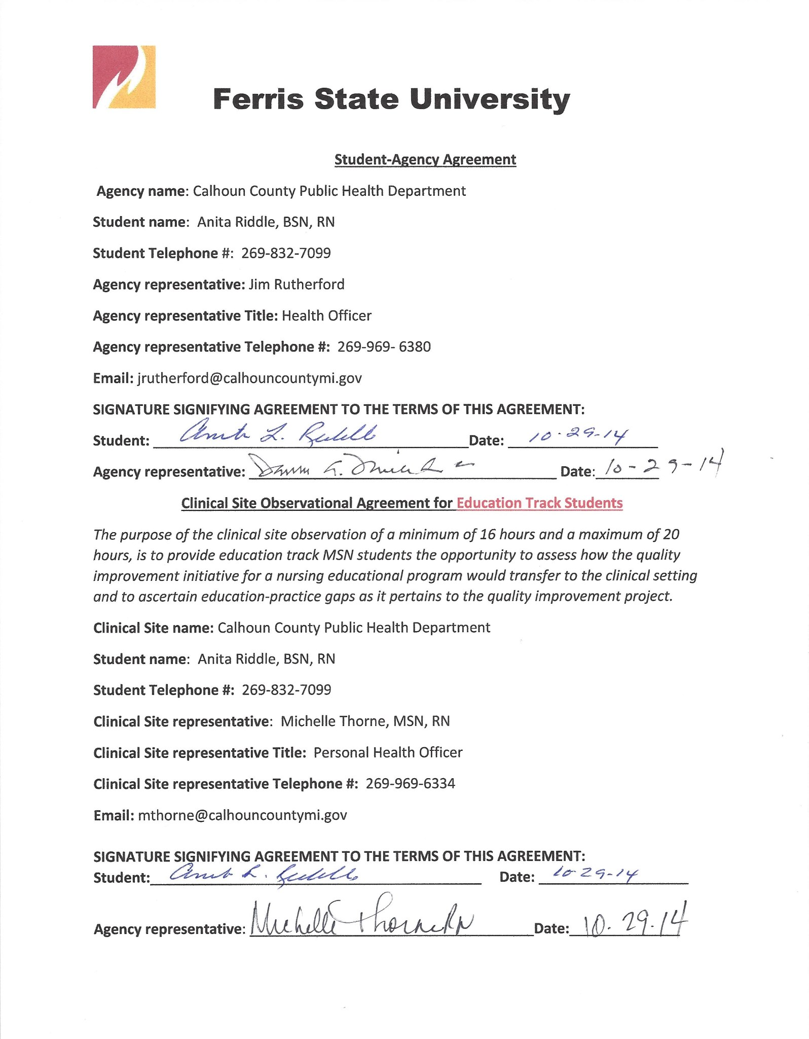
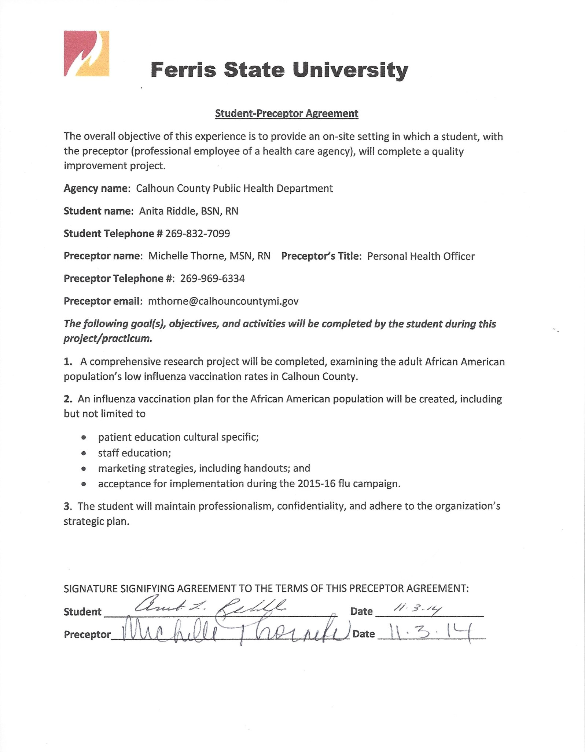
Appendix A QUALITY IMPROVEMENT PROJECT PROPOSAL PLANNING GUIDE
Improving Influenza Immunization Rates in the Adult African American Population in Calhoun County

Goals with QSEN/ANA Support | Sub-Objectives to meet Goal | Activities to meet Each Sub-objective | Timeline for each
Goal 1:  Identify the barriers preventing the African American population from seeking the influenza vaccination.  Meets QSEN Competency(ies)/KSA(s):  Patient-Centered-Care  Skills - Elicit patient values, preferences and needs during patient interviews (QSEN, 2014, “Graduate KSAs”).  Attitudes – Support patient-centered-care for those who values differ from your own (QSEN, 2014, “Graduate KSAs”).  Meets ANA Scope & Standards for specialty role:  Standard 2 – Identification of current issues and trends (ANA, 2010, p. 24).  1. Validates identified needs with the nurse, consumer, content experts, and other educators or disciplines (ANA, 2010, p. 24).  2. Documents identified needs in a manner that facilitates generation of purpose statements, educational objectives, program content, and evaluation criteria (ANA, 2010, p. 24).  Standard 4 – Planning (ANA, 2010, p. 26).  1. Individualizes content to the target population (e.g., educational level, experience, and preferred method of learning), the resources available, and the domains of learning (ANA, 2010, p. 26).  2. Markets the plan, using promotional materials that are accurate, comprehensive, and appealing to the target population (ANA, 2010, p. 26). | 1.1 Ensure the organization’s environment supports patient-centered care.  1.2 Consider the patient’s cultural beliefs and values as related to health care.  1.3 Form a health care partnership with the patient.  1.4 Utilize Calhoun County surveillance statistics related to the surrounding population’s sociocultural, demographic, health status, and environmental educational needs to identify an opportunity to educate a target population (ANA, 2013, p. 30).  1.5 Develop an education plan to accommodate the needs of an adult African American population.  1.6 Develop a marketing plan. | 1.1 Select educational focus which also supports the mission, vision, and values of the health department.  1.2 Review the spiritual beliefs, culture, and diversity of the target population’s race and ethnicity.  Determine age appropriate teaching methods and activities.  Choose educational setting in which the target audience will feel comfortable.  1.3 Use active listening skills when interacting with clients. Encourage active participation from the client in their health making decisions.  Communicate clearly.  1.4 Disseminate the information to appropriate health department staff, including non-nursing personnel. Encourage input from all departments involved.  1.5 The activities to achieve the identified competencies will be variable. The target populations will vary in age, learning styles, environments, and socioeconomic status. Education will take place in multiple settings such as schools, clinics, homes, churches, etc., and may be individual, family, or community based. Staff development will also be a focus and may include departments outside of the nursing profession.  1.6 Analyze the current marketing methods and media used. Consider new markets for advertising. | 1.1 February 8, 2015  1.2 March 20, 2015  1.3 Use throughout the project, with an emphasis during the community presentations to be delivered by 4/17/15.  1.4 Information will be disseminated to the key stakeholders throughout the project. Final expectations to staff by 3/27/15.  Final meeting with key stakeholders to evaluate the education program for implementation in the 2015/16 flu immunization season 4/24/15.  1.5 Deliver presentations to staff by 3/27/15  Deliver presentations in a minimum of two African American community settings by 4/17/15.  1.6 February 8, 2015
Goals with QSEN/ANA Support | Sub-Objectives to meet Goal | Activities to meet Each Sub-objective | Timeline for each
Goal 2:  Develop an evidence-based immunization education plan for staff, and the African American population to increase influenza vaccination rates in Calhoun County.  Meets QSEN Competency(ies)/KSA(s):  (Evidence-based practice)  Skills – Employ efficient and effective research methods (QSEN, 2014, “Graduate KSAs”).  (Quality Improvement)  Knowledge – Describe strategies for improving outcomes of care in the setting in which one is engaged in clinical practice (QSEN, 2014, “Graduate KSAs”).  Meets ANA Scope & Standards for specialty role:  Standard 7 - Quality of Professional Development Practice (ANA, 2010, p. 32)  1. Applies the nursing process in a responsible, accountable and ethical manner (ANA, 2010, p. 32).  2. Uses creativity and innovation to improve the quality of the learning experience (ANA, 2010, p. 32).  Standard 14 - Research (ANA, 2010, p. 40.  1. Support research activities that align with the organizational strategic plan (ANA, 2010, p. 40).  2. Disseminates research findings through activities such as presentations, publication, consultation, educational programs, courses, activities and use of other media (ANA, 2010, p. 40). | 2.1 Utilize multiple research resources when developing an education intervention for staff and clients.  2.2 Identify organizational system barriers, and personal barriers affecting the African American population.  2.3 Utilize tools such as the RCA and FMEA when making organizational changes to improve the vaccination rates of the African American population.  2.4 Review health literacy.  2.5 Develop patient education plan specific to increasing flu immunization rates in the target population.  2.6 Assure research resources are reliable and valid.  2.7 Assure research is disseminated to all key stakeholders. | 2.1 Use Calhoun County surveillance statistics related to the surrounding population’s sociocultural, demographic, health status, and environmental educational needs to identify an opportunity to educate a target population (ANA, 2013, p. 30).  2.2 Review the nursing process and rationale.  Review pertinent unit policies and procedures  2.3 Conduct an RCA with nursing clinic staff to evaluate current practices and gaps in practice. Include staff not at first RCA. Expand on first RCA.  2.4 Develop presentations/curriculums with the population’s health literacy in mind. Consideration will be given to the education level and age of the audience.  2.5 Be prepared to present material in different ways to accommodate the learners.  Presentations whether population based or staff oriented will promote interactive learner participation.  2.6 Pursue the expertise of the epidemiologist.  Utilize the PDSA method.  Review CCPHD’s strategic plan.  2.7 Review chosen health topic/issue with the Health Officer and the Personal Health Officer prior to dissemination of information.  Share information at staff meetings. | 2.1 February 8, 2015  2.2 February 8, 2015  2.3February 8, 2015  2.4 March 20, 2015  2.5 March 20, 2015  2.6 February 8, 2015  2.7 February 8, 2015

Appendix B

